IBM iAccess Client Solutions the Macro Manager Toolbar

1. Set-Up
   1. Start the “5250 session manager”, with “FTEI” as the configured session.
   2. In the menu bar select [ View -> Macro Manager]
   3. Diagram

      Description automatically generatedThe following toolbar described by “*Figure 1*” should appear:

Figure 1

1. Parts of the Macro Manager Toolbar
   1. Macro Filename Text Box
      1. This text field displays the current macro selected.
      2. The drop-down arrow in this field displays all playable macros.
   2. Edit Macro Properties Button
      1. This button opens the Host Access Macro Editor Form
      2. This form gives you the ability to edit the macros file properties, create macro instructions, link screens, and edit variables to be run with the macro.
   3. Delete Macro Button
      1. This button will delete the macro permanently.
   4. Play Macro Button
      1. This button signals the macro to be executed.
      2. If macro is paused, pressing the button with start the macro again.
   5. Record Macro Button
      1. This button starts the macro recording session.
   6. Stop Playing Macro Button / Stop Recording Macro Button
      1. This button stops the macro recording if currently recording.
      2. This button also stops the macro if it is currently being executed.
   7. Pause Playing Macro Button / Pause Recording Macro Button
      1. This button pauses the macro recording if currently recording.
      2. This button also pauses the macro if is currently being executed.
   8. Append To Recording Macro Button
      1. When recording a macro, pressing this button will allow you to append more instructions to the macro.
   9. Add A Prompt Button
      1. When recording a macro, pressing this button toggles a prompt making form.
      2. The prompt will execute in the sequence of when the prompt was made during the recording of the macro.
   10. Add A Smart Wait Button
       1. When recording a macro, pressing this button toggles a wait condition form.
       2. The wait condition will execute in the sequence of when the wait condition was made during the recording of the macro.
   11. Add An Extraction Button
2. Instructions on Macro Manager functions
   1. Creating a new macro:
      1. Press the “Record Macro Button”
      2. When the “Record Macro Form” appears select a place to save your macro file under the “Macro Location” section. Click the “New Radio Button” to create a new macro. Enter a name for the macro. Add a description of what your macro achieves. Press the “OK Button” when everything has been entered.
      3. When an Information message box stating, “Hotspots will be disabled while recording a macro. One the recording stops, hotspots will be enabled automatically” appears, click the “OK Button”.
      4. Start recording instructions, these instructions are keystrokes made by the user that the user wants to be repeated by the macro.
      5. After you are finished recording your macro click the “Stop Recording Button”.
      6. You will see the name of your finished macro in the “Macro Filename Text Box”.
   2. Deleting a macro:
      1. Select the macro that you want to be deleted by pressing the drop-down arrow in the “Macro Filename Text Bar” section. Once the chosen macro filename is clicked the name will be seen in the “Macro Filename Text Box”.
      2. Press the “Delete Macro Button”
      3. A prompt will be shown confirming if you want to delete the macro, press the “OK Button” to delete the macro.
   3. Playing a macro:
      1. Select the macro that you want to execute by pressing the drop-down arrow in the “Macro Filename Text Bar” section. Once the chosen macro filename is clicked the name will be seen in the “Macro Filename Text Box”.
      2. Press the “Play Macro Button”
      3. The macro will execute until the end of the macro script or unless an error occurs within the program environment in which the macro will stop playing immediately.
   4. Updating a macro:
      1. Press the “Record Macro Button”
      2. When the “Record Macro Form” appears, select the place where the macro file is saved under the “Macro Location” section. Click the “Existing Radio Button”. Select the name of the macro that you would like to update. Press the “OK Button” when everything has been entered.
      3. When an Information message box stating, “Hotspots will be disabled while recording a macro. One the recording stops, hotspots will be enabled automatically” appears, click the “OK Button”.
      4. Start recording instructions, these instructions are keystrokes made by the user that the user wants to be repeated by the macro.
      5. After you are finished recording your macro click the “Stop Recording Button”
      6. You will see the name of your finished macro in the “Macro Filename Text Box”.
   5. Appending to an existing macro:
      1. Press the “Record Macro Button”
      2. When the “Record Macro Form” appears, select the place where the macro file is saved under the “Macro Location” section. Click the “Existing Radio Button”. Select the name of the macro that you would like to update. Check the “Append to Existing” checkbox. Press the “OK Button” when everything has been entered.
      3. When an Information message box stating, “Hotspots will be disabled while recording a macro. One the recording stops, hotspots will be enabled automatically” appears, click the “OK Button”.
      4. Start recording instructions, these instructions are keystrokes made by the user that the user wants to be repeated by the macro.
      5. After you are finished recording your macro click the “Stop Recording Button”
      6. You will see the name of your finished macro in the “Macro Filename Text Box”.

**Note**: Each macro created is saved as a .mac file in the Macro Location chosen on creation

How To Bind a Macro

1. Popup Keypad
   1. Binding the Macro to a Button
      1. On the menu bar click, Edit -> Preferences -> Popup Keypad -> Customize.
      2. Click on “Macro” in the white box on the left of the “Customize Popup Keypad” window.
      3. Select the file location of where you saved the macros under the “Macro Location” section.
      4. Select the macro that you want to bind from the “Macro List”.
      5. A screenshot of a computer

         Description automatically generatedClick which button you want to bind the macro.
   2. Configuration
      1. On the menu bar click, Edit -> Preferences -> Popup Keypad -> Customize.
      2. Sticky Popup Keypad = TRUE
      3. Focus Back to Terminal = TRUE
      4. Scroll bar = TRUE
   3. Displaying Keypad
      1. On the menu bar click, Actions -> Popup Keypad
   4. Running the macro
      1. On the popup keypad press the button you have selected for the macro
2. Keyboard
   1. Binding the macro to keys
      1. On the menu bar click, Edit -> Preferences -> Keyboard.
      2. In the “Keyboard” window, Under the “Key Assignment” tab, in the “Category” combo box select “Macros.”
      3. Select the macro you want to bind.
      4. Click the “Assign a Key” button.
      5. The box above it will say “Press a key” and you will press the key binding you want to access the macro.
         1. Ex. If you set the key binding to “Shift + 3”, then you would be able to press those keys and run the macro.
      6. 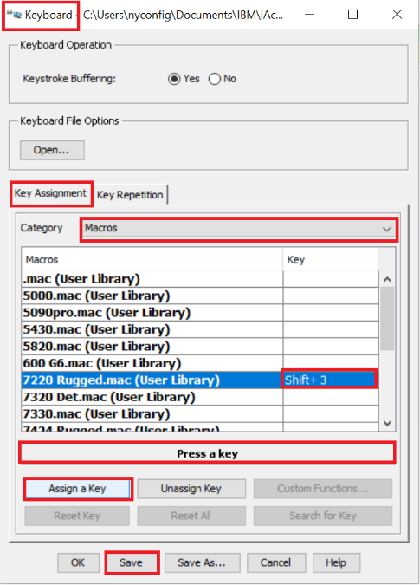Press the save button.
   2. Running the macro
      1. Pressing the key binding set to the macro that you want to be played.

Macro Updater

1. Prerequisites
   1. Download the “Macro Updater” program onto your local machine.
   2. Download the “text.js” file in the same location as the “Macro Updater” program.
   3. Create a folder called “Macros”. This folder will house all the .mac macro files.
2. Creating a macro
   1. In the navigation menu click the “Add Option” button
   2. A pop-window appears stating “Please enter a machine name:”
      1. Enter a machine name.
   3. After accepting the machine name, an “options.js” file will start downloading.
      1. The “options.js” file is a list of all the machine names.
   4. Save this file in the same location as the “Macro Updater” program.
   5. A list option for the machine name will be available in the machine name list in the “Macro Updater” program.
3. Updating a macro
   1. In the machine name list select the text box next to the machine name whose macro you want to update.
   2. In the text box write what BIOS version the machine is at
   3. Click the corresponding “Save” button.
   4. This will start downloading .mac macro file for the machine.
   5. Save this file in the “Macros” folder.
4. Deleting a macro
   1. Press the “X” button next to the corresponding machine name that you want to delete.
   2. A pop-up window will appear stating “Are you sure you want to delete this option?”
   3. After accepting this message, a “options.js” file will start downloading.
   4. Save this file in the same location as the “Macro Updater” program.
   5. The machine name that has been deleted will no longer be in the machine name list in the “Macro Updater” program.
5. Instructions
   1. In the navigation menu there is an “Instructions” button that will aid the user while using the program.